**AKSHAY MITTUR**

**1BM18CS010**

**CN Lab Writeup**

**DNS Server Configuration with cisco packet tracer**

**Procedure:**

1. Make Connections according to topology picture shown below
2. Add DNS server ip as 10.0.0.1 in PC0 config tab, and 10.0.0.2 as static ip address in FE 0/0
3. Add static ip address for server as 10.0.0.1 in its config FE 0/0 tab.
4. Go to services -> DNS and add a DNS configuration with the following attributes: Type – A Record, DNS service: ON, name: xyz.com, address: 10.0.01
5. Now go to the PC, go to http browser and search xyz.com in the search engine and see if it works. Debug accordingly.

**Observations:**

The DNS server works perfectly and we can access the aforementioned website.

**Topology:**

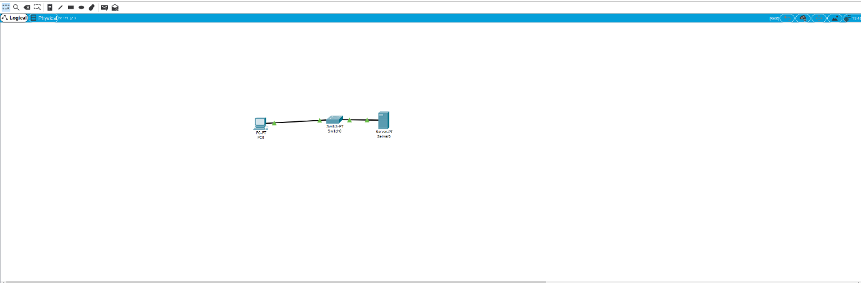

**Output:**

